**Go Menu**

**Go to a specific packet**

You can easily jump to specific packets with one of the menu items in the Go menu.

**The "Go to Packet" dialog box**

**Figure The "Go To Packet" dialog box**

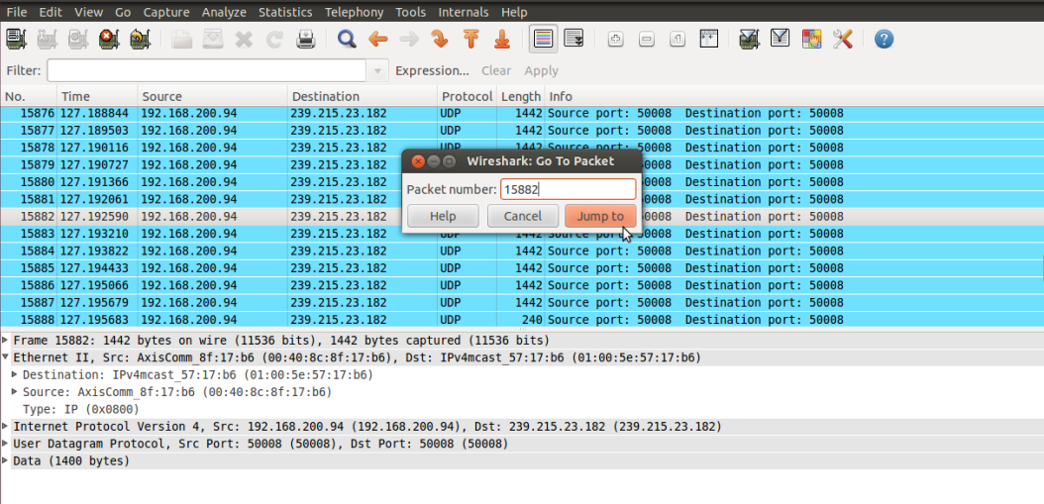

This dialog box will let you enter a packet number. When you press **OK**, Wireshark will jump to that packet.

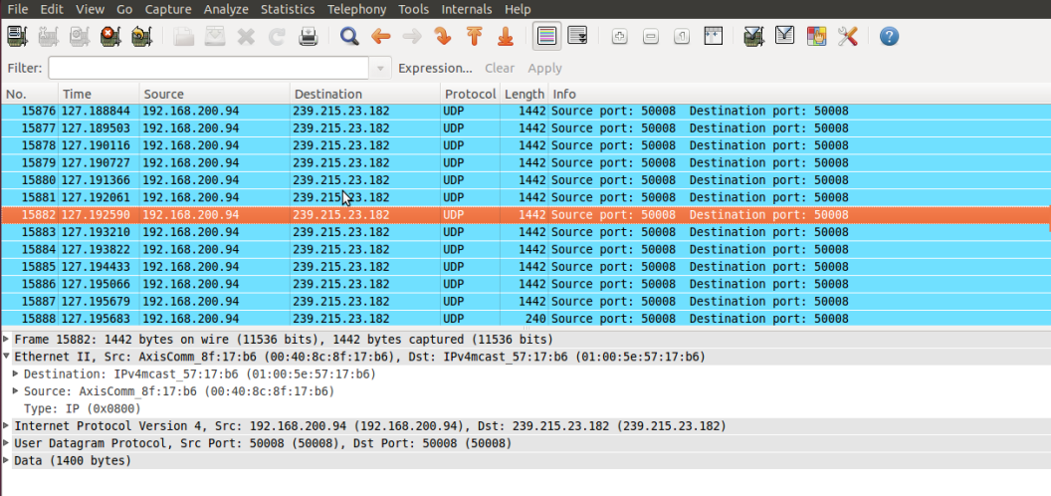

Enter the packet number and it will display the requested packet:

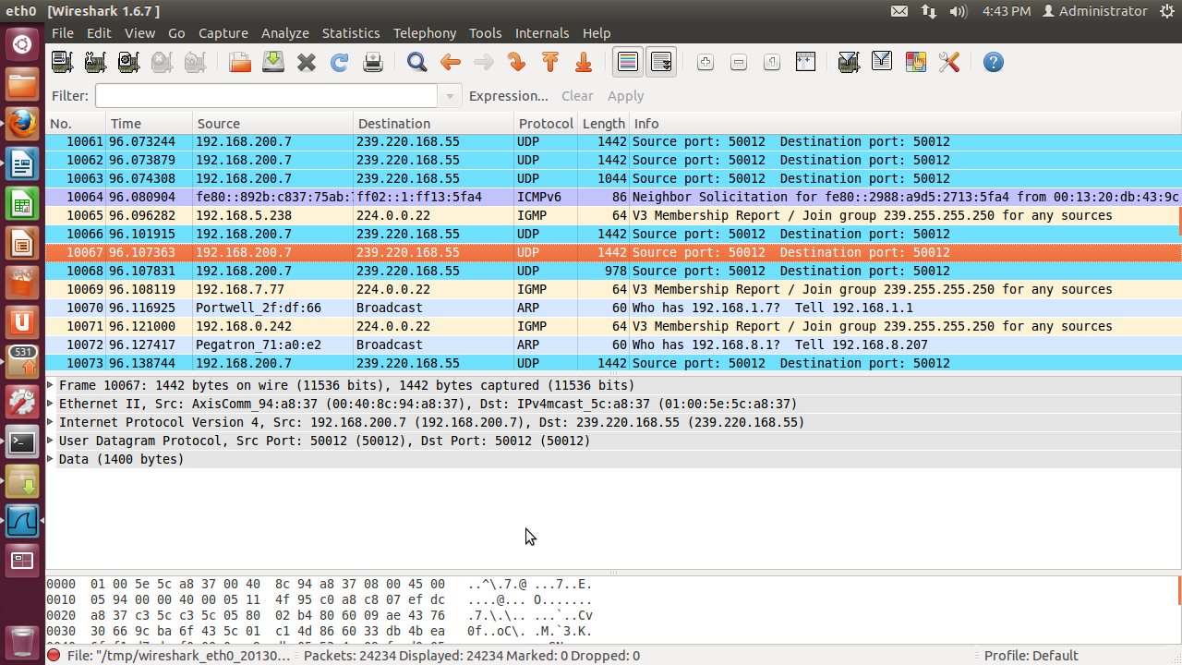

**The "Go Previous Packet" command**

Go back in the packet history, works much like the page history in current web browsers.

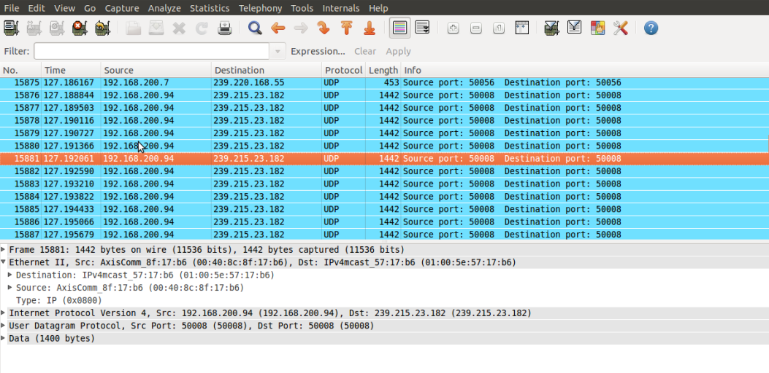

**The "Go Next Packet" command**

Go forward in the packet history, works much like the page history in current web browsers.

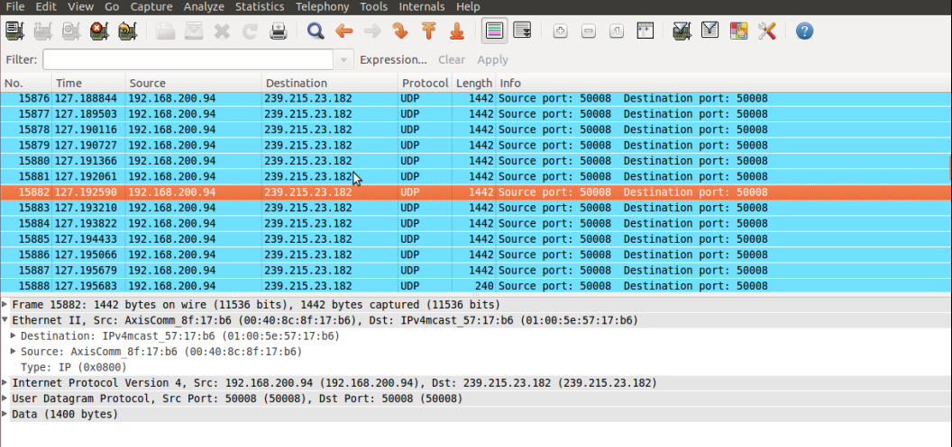

**The "Go to First Packet" command**

This command will simply jump to the first packet displayed.

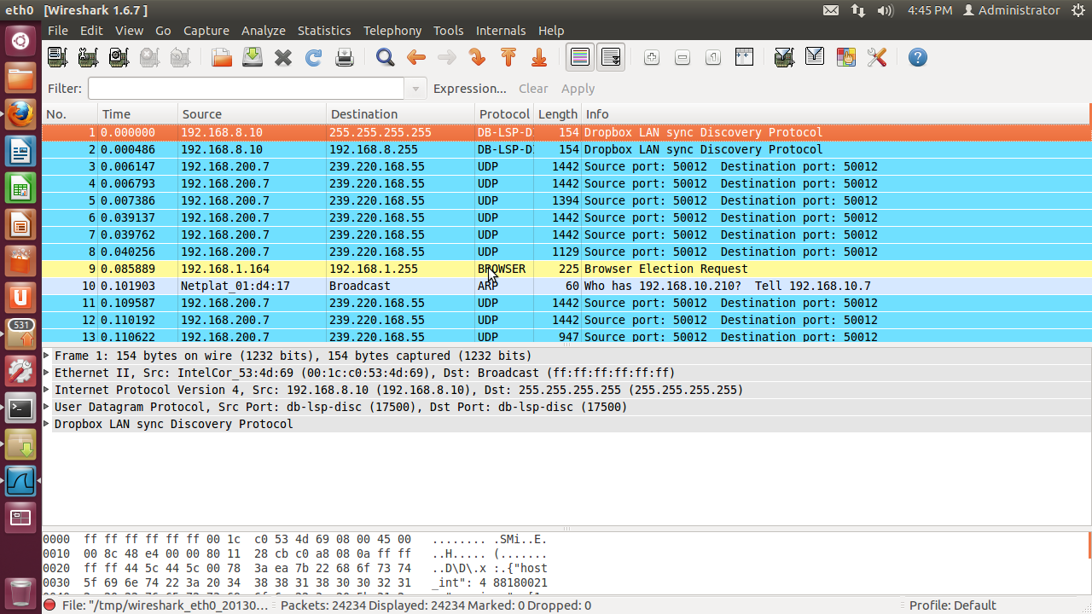

**The "Go to Last Packet" command**

This command will simply jump to the last packet displayed. 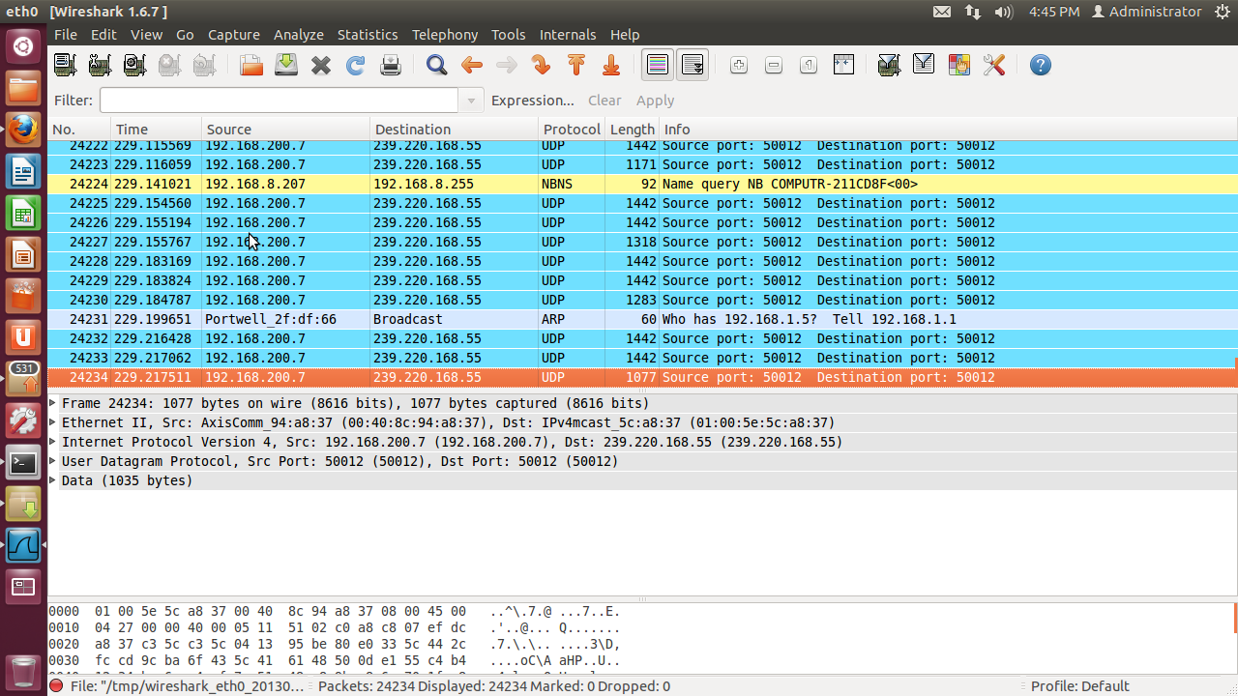

**The "Go to Previous Packet in conversation" command**

Go to the previous packet of the conversation (TCP, UDP or IP)

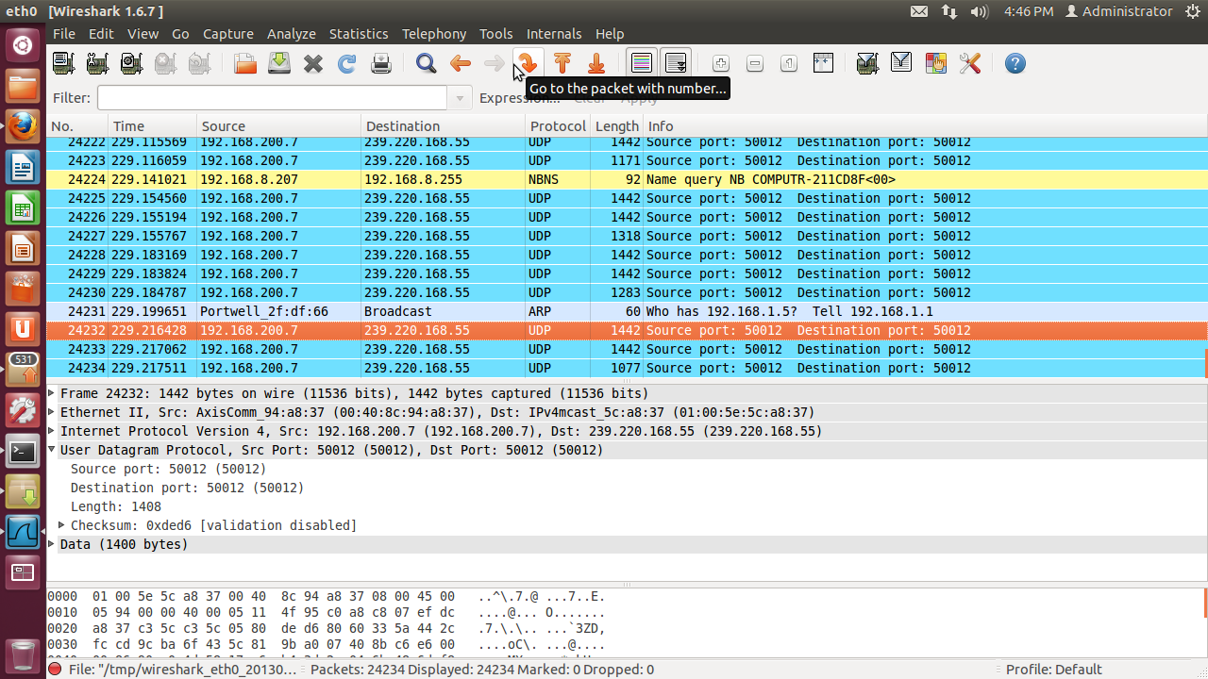

**The "Go to Next Packet in conversation" command**

Go to the next packet of the conversation (TCP, UDP or IP)

